

SCHOOL OF ENGINEERING

Department of Computer Science Engineering

CERTIFICATE

This is to certify that the Cornerstone project work entitled “EMPLOYEE LEAVE MANAGEMENT SYSTEM” is submitted by
N. RAMYA | (24B11CS308)
T. KUSUMA | (24B11CS435)
CH. GOWTHAM | (25B21CS074)
P. HEMANTH | (25B21CS016)

in partial fulfillment of the requirements for the award of the B.Tech. degree in Information Technology for the academic year 2025-2026.

Project Guide Head of the Department
Dr. K. Sreenu, Dr. T. Sudha Rani,
Assistant Professor, Assistant Professor,
Department of CSE Department of CSE

DECLARATION

We hereby declare that the Cornerstone project entitled “EMPLOYEE LEAVE MANAGEMENT SYSTEM” is original and is submitted to ADITYA UNIVERSITY, Surampalem, in partial fulfillment of the requirements for the award of the B.Tech. degree in
Computer Science Engineering. We further declare that this project work has not been submitted, either in full or in part, for the award of any degree in this or any other institution. We also confirm that this work complies with the Institutional Academic Integrity and AI Usage Policy

Place: Surampalem
Date:
By
N. RAMYA | (24B11CS308)
T. KUSUMA | (24B11CS435)
CH. GOWTHAM | (25B21CS074)
P. HEMANTH | (25B21CS016)

ACKNOWLEDGEMENT

It is with immense pleasure that we express our sincere gratitude to our Cornerstone Project Guide, Dr. k. Sreenu, Assistant Professor, who has guided us throughout the project. His valuable support, encouragement, and guidance have greatly contributed to the successful completion of this work.
We would like to thank our Deputy Heads of the Department, Dr. K. Chandra Sekhar, Associate Professor and Dr. Hari Jyothula, Associate Professor, Department of CSE, for their support and valuable suggestions.
Our deepest thanks to our Head of the Department Dr. T. Sudha Rani, Associate Professor, for her inspiration and for providing all the necessary facilities and resources required for this project.
We also extend our sincere thanks to Dr. M. V. Rajesh ,Associate Dean, School of Engineering for their encouragement and support during the course of our project.
We would like to express our sincere gratitude to Dr. G. Suresh, Registrar, (Engineering & Sciences), Dr. S. Rama Sree, Pro Vice-Chancellor (Academics), Dr. M.B. Srinivas, Vice-Chancellor, Dr. M. Sreenivasa Reddy, Deputy Pro Chancellor and Management, Aditya University for providing excellent infrastructure and state-of-the-art laboratories.
Finally, we would like to thank the faculty members, lab technicians, non-teaching staff, and our friends who have directly or indirectly supported us in completing this Cornerstone project successfully.

Table of contents

CONTENTS | PAGE NO
ABSTRACT | i
LIST OF FIGURES | ii
LIST OF TABLES | iii
ACRONYMS | iv
1. INTRODUCTION | 1
1.1 Brief Information about the Project | 1
1.2 Motivation and Contribution of Project | 1
1.3 Objectives of the Project | 1
1.4 Scope of the Project | 2
2. SYSTEM ANALYSIS | 3
2.1 Functional Requirements | 3
2.2 Non-Functional Requirements | 4
2.3 Requirements Specification | 4
2.3.1 Minimum Hardware Requirements | 4
2.3.2 Software Requirements | 4
3. TECHNOLOGY DESCRIPTION | 5
3.1 Programming Language | 5
3.1.1 Introduction to Java | 5
3.2 Framework / Libraries | 5
3.2.1 Introduction to Swing | 5
3.3 Database Technology | 5
3.3.1 JDBC (Java Database Connectivity) | 6
3.3.2 MySQL Database | 6
3.4 Tools & IDEs | 6
3.4.1 Visual Studio Code | 6
4. DATABASE DESIGN | 7
4.1 Database Tables | 7
4.2 Table Structure | 7
4.3 Keys and Constraints | 9
4.4 Table Relationships | 10
5. SYSTEM DESIGN | 11
5.1 System Architecture | 11
5.2 Modules Description | 12

- SYSTEM IMPLEMENTATION 13
- CONCLUSION 17
- FUTURE ENHANCEMENTS 18
- REFERENCES 20
APPENDIX (Sample Code) 21
APPENDIX (SQL Queries) 22

ABSTRACT
The Employee Leave Management System is a Java-based application developed using J2SE with integrated database support to automate and manage the employee leave process within an organization. The system is designed to perform essential operations such as employee registration, leave application, leave approval and rejection, leave balance management, and leave history tracking through a structured and user-friendly interface. By utilizing JDBC for database connectivity, the application ensures persistent storage of employee records, leave details, and approval logs, thereby reducing manual paperwork, minimizing errors, and improving efficiency and transparency in leave administration

 | LIST OF FIGURES
Figure no. | Figure Title | Page no.
1 | Login Screen of Employee Leave Management System | 13
2 | Main Menu Screen of Employee Leave Management System | 14
Apply Leave Screen of Employee Leave Management
  - System 14
View Leave Records Screen of Employee Leave Management
  - System 15
Admin Approval Screen of Employee Leave
  - Management System 15
Admin Approval Screen of Employee Leave Management
  - System 16

LIST OF TABLES
Table Title | Page No.
Employee Relational Database Table | 7
Leave Type Relational Database Table | 7
Leave Request Relational Database Table | 8
Leave Approval Relational Database Table | 9

ACRONYMS

- EMS : Employee Leave Management System
- JDBC : Java Database Connectivity
- CLI : Command Line Interface
- SQL : Structured Query Language

1.INTRODUCTION

Brief Information about the Project
The Employee Leave Management System (ELMS) is a desktop-based application developed to manage employee leave information efficiently within an organization. It provides a centralized platform to store, retrieve, update, and track leave records such as leave applications, approvals, and leave balances in a structured manner. The system replaces traditional manual methods like paper records and spreadsheets with a computerized solution, thereby improving data accuracy, reducing redundancy, and ensuring easy accessibility of information. The application is developed using Core Java, where the backend operations are handled through a console-based approach. JDBC is used for database connectivity, and MySQL is used for storing and managing leave-related data. The system is designed to be simple, efficient, and suitable for organizations such as colleges, offices, and companies where effective leave management is essential.

Motivation and Contribution of Project
In many organizations, employee leave information is still maintained using manual registers or basic spreadsheet tools, which leads to inefficiencies such as errors in leave balance calculation, delays in approval processes, difficulty in tracking leave history, and increased chances of data loss. These limitations motivated the development of the Employee Leave Management System. The key contributions of this project include:
- Providing a digital solution for managing employee leave records

- Reducing manual effort and paperwork in leave processing
- Improving accuracy in leave balance calculation and record maintenance

- Enabling quick application, approval, and tracking of leave requests

- Enhancing data security through controlled access and structured storage
This system simplifies employee data management and improves overall organizational efficiency.

Objectives of the Project
The main objectives of the Employee Leave Management System are:
- To develop a user-friendly application for managing employee leave data
- To store leave information such as leave applications, approvals, and balances in a

structured database

- To provide functionalities for applying, approving, rejecting, and updating leave requests
- To enable quick Tracking of Leave status and history for employees

- To maintain accurate leave balance records and display them in an organized format

Scope of the Project
The Employee Leave Management System can be used in small and medium-sized organizations such as offices, colleges, and institutions to manage employee leave records efficiently. It supports operations such as applying for leave, approving or rejecting leave requests, tracking leave balances, viewing leave history, and generating reports in an organized manner. The system provides a simple and user-friendly interface for maintaining leave data in a centralized database, ensuring easy access, better accuracy, and improved management of employee leave information.

SYSTEM ANALYSIS

Functional Requirements
Functional requirements define the core operations and functionalities that the Employee Leave Management System (ELMS) must perform to effectively manage employee leave-related information. The functional requirements of Employee Leave Management System (ELMS) are:

Apply leave
The system should allow employees to apply for leave by entering details such as leave type, start date, end date, and reason. Proper validation should be applied to ensure correct data entry.

Approve/Reject Leave Requests
The system should allow managers to review leave requests submitted by employees and approve or reject them. A confirmation mechanism and option to add comments should be provided.

Update Employee Requests
The system should provide functionality to modify or update leave requests before approval. Employees should be able to edit or cancel their requests if require.

Track Leave Status
The system should allow employees to check the status of their leave requests (Pending, Approved, or Rejected). The system should display accurate and up- to-date information.

View Leave Records
The system should display all leave records in a structured format, enabling users to view details such as leave dates, type, status, and history..

Manage Leave Types and Policies
The system should allow administrators to manage different types of leaves (such as sick leave, casual leave, annual leave), define maximum leave limits, and update policies as required.

Generate Reports
The system should generate reports such as employee leave history, monthly leave summaries, and overall leave statistics in an organized format.

Non-Functional Requirements
Non-functional requirements define the quality attributes and performance standards that the Employee Leave Management System (ELMS) must satisfy.

Performance
The system should respond quickly to operations such as applying for leave, approving requests, and retrieving leave records without delays.

Security
Only authorized users should be able to access the system based on their roles (employee, manager, admin). Proper authentication and access control should be implemented to protect sensitive leave data.

Usability
The system should be simple and user-friendly, allowing users to easily apply for leave, track status, and manage requests without difficulty.

Reliability
The system should operate consistently and handle errors effectively without loss of leave data or system failure.

Scalability
The system should be capable of handling an increasing number of employees, leave requests, and data without affecting performance.

Requirements Specification
This section specifies the hardware and software needed to run the system.

Minimum Hardware Requirements
          - Processor: Intel i3 or above
          - RAM: 4 GB (minimum)
          - Hard Disk: 20 GB free space
          - Monitor: Standard display
          - Keyboard and Mouse

Software Requirements
          - Operating System: Windows 7/10/11

Programming Language: Java
          - IDE: VS Code
          - Database: Mysql Database
          - Connectivity: JDBC

TECHNOLOGY DESCRIPTION

Programming Language

Introduction to Java
Java is a high-level, object-oriented programming language developed by Sun Microsystems. It is widely used for developing desktop, web, and enterprise applications due to its platform independence and robustness.
In the Employee Leave Management System, Java is used to implement the core functionality of the application. It handles operations such as applying for leave, approving or rejecting requests, tracking leave status, and managing leave records. Java provides features like object-oriented programming, exception handling, and strong memory management, which help in building a reliable and efficient system.
One of the main advantages of Java is that it is platform-independent, meaning the program can run on any system that has a Java Virtual Machine (JVM). This makes it suitable for developing portable applications like the Employee Leave Management System.

Framework / Libraries

Console-Based Interface
In this project, a console-based approach is used instead of graphical frameworks like Swing. The system interacts with users through the command prompt, where users can input data and receive outputs in text format.
The console-based interface provides simplicity and reduces system complexity while still allowing efficient interaction with the system. It enables functionalities such as:
          - Login through command prompt
          - Applying for leave by entering required details
          - Viewing leave status and history
          - Manager approval or rejection of requests
          - Display Leave Records
This approach makes the system lightweight, easy to implement, and suitable for learning backend logic and database integration.

Database Technology

The Employee Leave Management System uses a relational database to store and manage leave-related information in a structured manner. The database ensures efficient data storage ,retrieval, and manipulation which is essential for maintaining accuracy and

consistency in the system. In this project, MYSQL is used as the backend, and JDBC is used for connecting the Java application to the database.

JDBC (Java Database Connectivity)
JDBC is an API (Application Programming Interface) used in Java to connect and interact with databases. It allows Java applications to execute SQL queries and retrieve or update data in the database.
In the Employee leave Management System, JDBC is used to connect the Java application with the MySQL database. It performs operations such as:
          - Establishing a connection to the database
          - Executing SQL queries (INSERT, UPDATE, DELETE, SELECT)
          - Retrieving leave-related data from the database
          - Closing the database connection
JDBC acts as a bridge between the application and the database, ensuring smooth communication and data transfer. It helps in maintaining data consistency and enables efficient data handling.

MySQL Database
MySQL is a popular open-source relational database management system used for storing and managing structured data. It provides high performance, reliability, and ease of use.
In the Employee Leave Management System, MySQL is used to store data such as employee details, leave types, leave requests, approvals, and leave balances. It supports SQL for data manipulation and ensures data integrity through constraints like primary keys and foreign keys.

Tools & IDEs

Visual Studio Code
Visual Studio Code (VS Code) is used as the development environment for the Employee leave Management System. It is a lightweight code editor that supports Java programming through extensions. VS Code provides features such as syntax highlighting, code completion, and debugging support, which help improve coding efficiency. It’s simple and user-friendly interface makes it suitable for developing and testing the application.

DATABASE DESIGN

Database Tables
The Employee Leave Management System uses a relational database to store leave- related information in a structured manner. The database consists of four main tables: Employee, Leave_Type, Leave_Request, and Leave_Approval.

- The Employee table stores details of employees such as employee ID, name, department, manager, and leave balance.
- The Leave_Type table stores different types of leaves available in the organization, such as casual leave, sick leave, and annual leave.
- The Leave_Request table stores all leave applications submitted by employees, including leave dates, type, and status.
- The Leave_Approval table stores information about approval or rejection of leave requests by managers.

This structured separation of data helps in reducing redundancy, maintaining data integrity, and improving overall data organization.

Table Structure
        - Employee Table:

Column Name | Data Type | Description | Constraint
emp_id | NUMBER | Unique employee ID | Primary Key
emp_name | VARCHAR2(100) | Employee name | Not Null
dept_id | NUMBER | Department ID | Foreign Key
manager_id | NUMBER | Reporting manager ID | Foreign Key
leave_balance | NUMBER | Available leave days | -

        - Leave_Type Table :

Column Name | Data Type | Description | Constraint
leave_type_id | NUMBER | Unique leave type ID | Primary

Column Name | Data Type | Description | Constraint
 |  |  | Key
type_name | VARCHAR2(50) | Leave type name (Annual, Sick, Casual) | Not Null
max_days | NUMBER | Maximum allowed days | Not Null
carry_forward | VARCHAR2(5) | Can carry forward? (YES/NO) | -

4.2.3.Leave_Request Table:

Column Name | Data Type | Description | Constraint
request_id | NUMBER | Unique request ID | Primary Key
emp_id | NUMBER | Employee ID | Foreign Key
leave_type_id | NUMBER | Leave type ID | Foreign Key
from_date | DATE | Leave start date | Not Null
to_date | DATE | Leave end date | Not Null
total_days | NUMBER | Total leave days | -
status | VARCHAR2(20) | Request status (Pending, Approved, Rejected) | -
applied_date | DATE | Application date | -

Leave_Approval Table:

Column Name | Data Type | Description | Constraint
approval_id | NUMBER | Unique approval ID | Primary Key
request_id | NUMBER | Leave request ID | Foreign Key

Column Name | Data Type | Description | Constraint
manager_id | NUMBER | Approving manager ID | Foreign Key
approval_date | DATE | Date of approval | -
comments | VARCHAR2(500) | Approval/Rejection comments | -
approval_status | VARCHAR2(20) | Approved/Rejected | -

Keys and Constraints
Keys and constraints are used to maintain data integrity and ensure accurate storage of leave-related information in the database.

Primary Keys:
- Emp_ID in Employee table
- Leave_Type_ID in Leave_Type table
- Request_ID in Leave_Request table
- Approval_ID in Leave_Approval table

Foreign Keys:
- Emp_ID in Leave_Request table references Emp_ID in Employee table
- Leave_Type_ID in Leave_Request table references Leave_Type_ID in Leave_Type table
- Request_ID in Leave_Approval table references Request_ID in Leave_Request table

NOT NULL Constraint:
- Important fields such as employee ID, employee name, leave type, and leave dates cannot be left empty

Data Type Constraints:
- Each field accepts only valid data types (such as NUMBER, VARCHAR, DATE) to ensure correctness
These constraints help in maintaining consistency, ensuring referential integrity, and avoiding duplicate or invalid data.

Table Relationships
The Tables in the Employee Leave Management System are related to each other to maintain proper data organization and integrity.
- The Employee and Leave_Request tables are related through the Emp_ID field.
- Each employee can have multiple leave requests.
- Each leave request belongs to only one employee.

- The Leave_Type and Leave_Request tables are related through the Leave_Type_ID field.
- One leave type can be associated with multiple leave requests.
- Each leave request is linked to only one leave type.

- The Leave_Request and Leave_Approval tables are related through the Request_ID field.
- Each leave request has one corresponding approval record.
- Each approval record belongs to a specific leave request.

These relationships represent one-to-many (1:M) associations and help in maintaining data consistency and proper linkage between different tables in the system.

.

SYSTEM DESIGN

System Architecture
The Employee Leave Management System follows a three-layer architecture:

Presentation Layer (User Interface)
  - Implemented using a console-based interface
  - Allows users to interact with the system by entering inputs and viewing outputs

Application Layer (Business Logic)
  - Processes user inputs and controls system operations
  - Performs operations such as applying for leave, approving/rejecting requests, tracking leave status, and generating reports

Data Layer (Database)
  - Stores employee ,leave type, leave request, and approval data
  - Managed using MySQL Database with JDBC connectivity
This architecture ensures better organization, security, and maintainability data security, and efficient management of leave-related operations.

Modules Description
The system is divided into the following modules:

Login Module
  - Handles user authentication using username and password
  - Provides access based on roles such as employee, manager, and admin

Employee Module
  - Allows employees to apply for leave
  - Enables viewing of leave balance and leave history
  - Allows checking the status of leave requests

Admin/HR Module
  - Allows managers to view leave requests submitted by employees
  - Approves or rejects leave requests
  - Provides option to add comments during approval process
  - Manages employee details and leave policies
  - Adds or updates leave types and leave limits
  - Monitors overall system activities

Reports Module
  - Generates reports such as leave history, monthly summaries, and absenteeism reports
  - Displays data in an organized format

Database Connectivity Module
  - Connects the Java application with MySQL database using JDBC
  - Executes SQL queries such as INSERT, UPDATE, DELETE, and SELECT

User Interface Module
  - Provides a console-based interface for user interaction
  - Handles input and output operations through the command prompt

SYSTEM IMPLEMENTATION

Login Screen:
Displays the login interface where the user enters username and password.

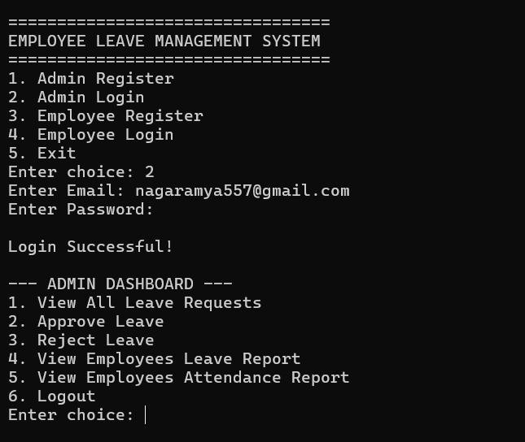
The above module explains about the Admin functionality of the Employee Leave Management System, which allows administrators to securely log in and manage employee leave operations through a command-line interface. In this screen, the admin selects the login option, enters their email and password, and successfully accesses the system. After login, the Admin Dashboard is displayed, providing various management features such as viewing all leave requests, approving or rejecting leave applications, and generating reports for employee leave and attendance. This module ensures efficient monitoring and control of employee activities, making the leave management process systematic and organized.
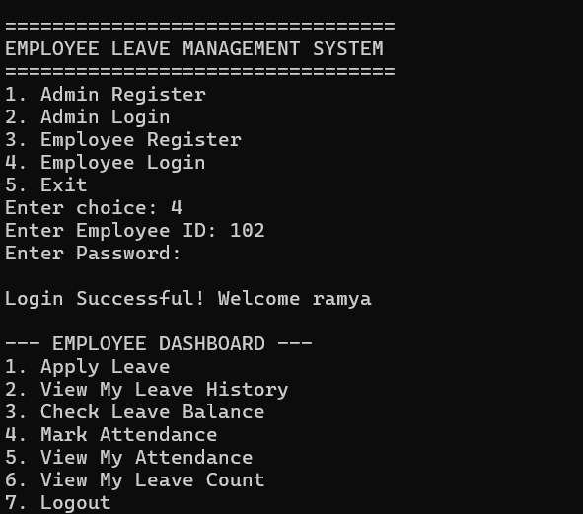

The above module explains about the Employee Leave Management System interface where an employee logs into the system using their ID and password. After a successful login, the system displays the employee dashboard, which provides various functionalities such as applying for leave, viewing leave history, checking leave balance, marking attendance, viewing attendance records, and tracking the total leave count. This module highlights how the system enables employees to efficiently manage their leave and attendance details in a structured and user-friendly manner.

Main Menu Screen:
Provides options such as Apply Leave, View Leave Balance, Check Leave Status, Approve/Reject Requests, and Generate Reports.
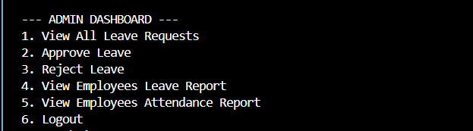
The above module explains about the Admin Dashboard of the Employee Leave Management System, where the administrator manages and controls employee leave activities. This interface provides options to view all leave requests submitted by employees, approve or reject those requests, and generate reports related to employees’ leave and attendance. It also includes a logout option for secure exit. This module highlights how the admin can efficiently monitor, analyze, and make decisions regarding employee leave and attendance in an organized manner.
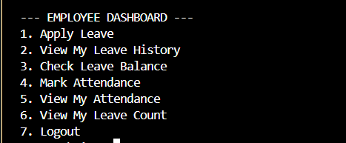

The above module explains about a terminal-based Employee Dashboard interface, which serves as a centralized hub for managing workplace administrative tasks. The system presents a numbered menu allowing users to perform essential HR functions, such as applying for leave, checking leave history and balances, and marking attendance. Additionally, employees can review their attendance records and total leave counts before securely exiting the system via the logout option. This streamlined, text-driven interface is designed for efficiency, providing clear navigation for personnel to track their time and time-off requests.

Apply Leave Screen:

Shows the interface used by employees to enter leave details such as leave type, start date, end date, and reason for applying leave.
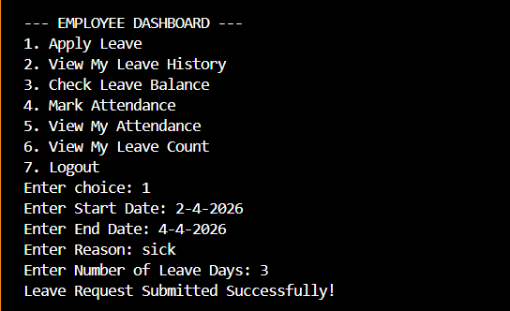

The above module explains about the functional workflow of the Apply Leave feature within an automated Employee Dashboard system. In this specific scenario, the user selects the first option from the main menu and is subsequently prompted to input critical leave details, including the start and end dates, the reason for absence (specified here as "sick"), and the total number of leave days. Upon entering this data, the system validates the request and provides immediate feedback with a confirmation message stating, "Leave Request Submitted Successfully!" This demonstration highlights the back-end logic's ability to capture user input and transition from a menu selection to a completed administrative transaction.

View Leave Records Screen:
Displays all leave records including leave type, dates, and status in a structured format..

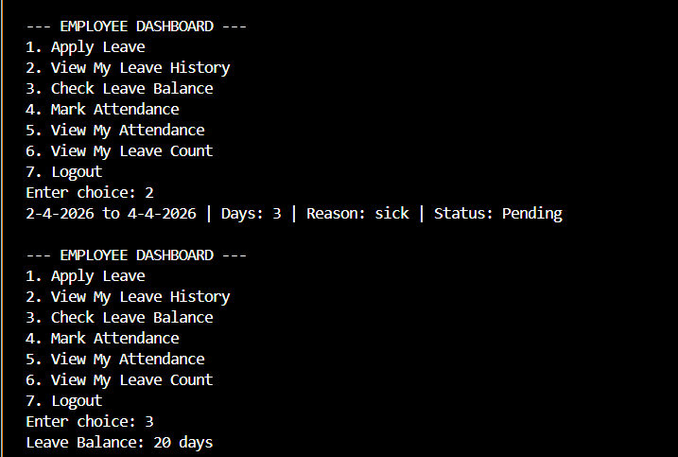
The above module explains about the data retrieval capabilities of the Employee Dashboard, specifically focusing on the View My Leave History and Check Leave Balance functionalities. By selecting option two, the system displays a detailed log of previous requests, including date ranges, the reason for the leave, and the current approval status, which is shown as "Pending." Furthermore, the screenshot demonstrates the process of selecting option three, which prompts the system to fetch and display the user's remaining Leave Balance (20 days). This reflects a robust backend integration where user-specific data is stored and displayed in real-time, allowing employees to track their time-off status and availability with ease.

Admin Approval Screen:
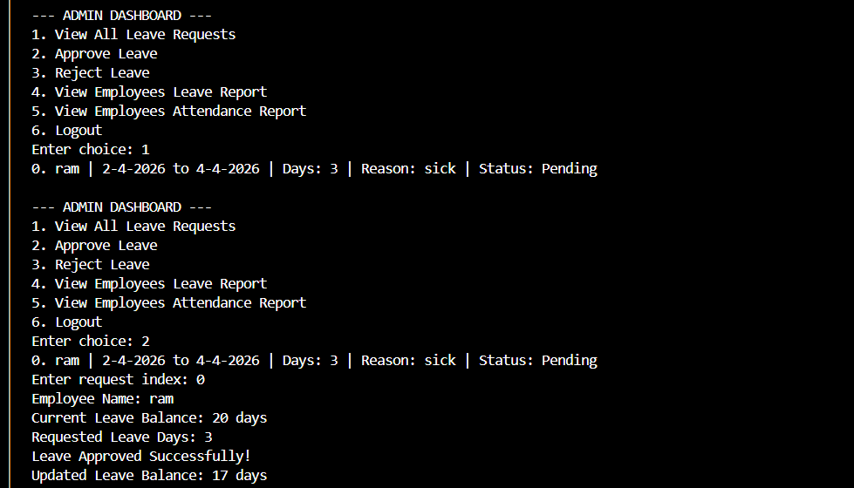
Shows the interface used by managers to approve or reject leave requests submitted by employees.

The above module explains about the supervisory controls within the Admin Dashboard, specifically the process of reviewing and approving staff time-off requests. By selecting the View All Leave Requests option, the administrator can see a consolidated list of pending applications, such as the one submitted by "ram." The interface further demonstrates the Approve Leave workflow, where the admin selects a specific request index to view the employee's current balance and the requested duration. Upon approval, the system automatically calculates and displays the Updated Leave Balance (deducting the days from the total), providing a seamless and transparent method for managing organizational leave data and ensuring record accuracy.
Veiw employee leave report

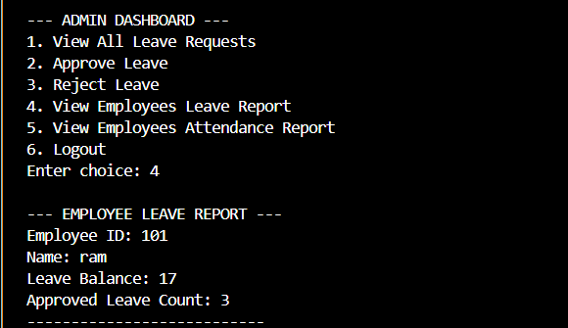

The above module explains about the reporting functionality of the Admin Dashboard, specifically the View Employees Leave Report feature. By selecting option four, the administrator can access a detailed summary of an individual staff member's leave status, identifying them by their Employee ID and name. The report provides a clear snapshot of the employee's current Leave Balance alongside their total Approved Leave Count. This high-level overview allows management to monitor usage trends and ensure that leave records are accurately maintained across the organization's workforce.

7. CONCLUSION
The Employee Leave Management System has been successfully developed to manage employee leave information in an efficient and organized manner. The system replaces manual leave tracking methods with a computerized solution, thereby reducing errors, saving time, and improving the accuracy of leave records.
The application provides essential functionalities such as applying for leave, approving or rejecting requests, tracking leave status, and maintaining leave history through a simple and effective interface. By using technologies like Core Java, JDBC, and MySQL database, the system ensures reliable performance, secure data handling, and easy access to leave-related information.
Overall, the system improves the efficiency of managing employee leave processes and reduces the workload of administrative staff and managers. It also provides a scalable solution that can be further enhanced in the future by adding features such as web-based access, role-based authentication, and advanced report generation.
In conclusion, the Employee Leave Management System meets the project objectives and serves as an effective tool for managing employee leave records in organizations.

8.FUTURE ENHANCEMENTS
The Employee Leave Management System developed in this project provides basic functionalities for managing employee leave records. However, the system can be further enhanced by adding advanced features to improve its functionality and usability. Some possible future enhancements include:

Payroll Integration:
Integrating leave data with payroll to calculate salaries based on leave deductions and generate payslips

Attendance Management:
Adding attendance tracking and linking it with leave records for better workforce management

Web-Based Application:
Converting the desktop application into a web-based system to enable remote access and real-time updates

Multi-User Support:
Allowing multiple users to access the system simultaneously with proper role-based access control

Email/SMS Notifications:
Sending automatic notifications to employees and managers regarding leave applications and approvals

Improved User Interface:
Enhancing the system by adding a graphical user interface for better user experience

These enhancements can make the system more scalable, secure, and suitable for real- time organizational use.

9. REFERENCES
The following references were used during the development of the Employee Leave Management System:
- Herbert Schildt, Java: The Complete Reference, Oracle Press, 11th Edition.

- E. Balagurusamy, Programming with Java, McGraw Hill Education.

- Korth, Silberschatz, Sudarshan, Database System Concepts, McGraw Hill.
- MySQL Documentation, https://dev.mysql.com/doc/
- Java Documentation (Oracle), https://docs.oracle.com/javase
- JDBC Tutorial – GeeksforGeeks, https://www.geeksforgeeks.org/jdbc/
- MySQL Tutorial – TutorialsPoint, https://www.tutorialspoint.com/mysql
W3Schools Java Tutorial, https://www.w3schools.com/java/

APPENDIX

Sample Code

Database Connection Code:
The following code establishes a connection between the Java application and the Oracle database using JDBC.

DBConnection.java:
import java.sql.*;
public class DBConnection {
public static Connection getConnection() { Connection con = null;
try {
Class.forName("com.mysql.cj.jdbc.Driver"); con = DriverManager.getConnection(
"jdbc:mysql://localhost:3306/elms", "root", "password");
} catch (Exception e) { System.out.println(e);
}
return con;
}
}

Insert Employee Record:
This code is used to add a new employee into the database.

InsertEmployee.java:
import java.sql.*;
public class InsertLeaveRequest {
public static void main(String[] args) { try {
Connection con = DBConnection.getConnection();
String query = "INSERT INTO leave_request VALUES(?,?,?,?,?,?,?,?)";
PreparedStatement pst = con.prepareStatement(query);

pst.setInt(1, 1); // request_id pst.setInt(2, 101); // emp_id
pst.setInt(3, 1); // leave_type_id
pst.setDate(4, Date.valueOf("2026-03-20")); // from_date pst.setDate(5, Date.valueOf("2026-03-22")); // to_date pst.setInt(6, 3); // total_days
pst.setString(7, "Pending"); // status
pst.setDate(8, Date.valueOf("2026-03-18")); // applied_date int i = pst.executeUpdate();
if (i > 0)
System.out.println("Leave Request Added Successfully"); con.close();
} catch (Exception e) { System.out.println(e);
}
}
}

SQL Queries

Create Employee Table:
CREATE TABLE employee ( emp_id INT PRIMARY KEY,
emp_name VARCHAR(100) NOT NULL,
dept_id INT, manager_id INT, leave_balance INT
);

Create Leave_Type Table:
CREATE TABLE leave_type ( leave_type_id INT PRIMARY KEY, type_name VARCHAR(50) NOT NULL, max_days INT NOT NULL, carry_forward VARCHAR(5)
);

Create Leave_Request Table:
CREATE TABLE leave_request ( request_id INT PRIMARY KEY, emp_id INT,
leave_type_id INT,
from_date DATE NOT NULL, to_date DATE NOT NULL, total_days INT,
status VARCHAR(20), applied_date DATE,
FOREIGN KEY (emp_id) REFERENCES employee(emp_id),
FOREIGN KEY (leave_type_id) REFERENCES leave_type(leave_type_id)
);

Create Leave_Approval Table:
CREATE TABLE leave_approval ( approval_id INT PRIMARY KEY, request_id INT,
manager_id INT, approval_date DATE, comments VARCHAR(500),
approval_status VARCHAR(20),
FOREIGN KEY (request_id) REFERENCES leave_request(request_id)
);

